# Find out how many times Theft with over $500 happened in 2020 until 2020-10-14

SELECT CASE_NUMBER, DATE, PRIMARY_TYPE, DESCRIPTION, ARREST FROM finalproject.crime WHERE PRIMARY_TYPE = 'THEFT' ORDER BY DATE;

SELECT COUNT(*) FROM finalproject.crime WHERE PRIMARY_TYPE = 'THEFT' AND DESCRIPTION = 'OVER $500' AND DATE < '2020-10-15 00:00:00';

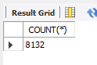

# Find out the most battery happened in which police district order by the amount of batteries

SELECT

pd.DISTRICT_NAME,

COUNT(DISTINCT (c.CRIME_ID)) AS BATTERY_Number

FROM

finalproject.crime AS c

JOIN

finalproject.fact_table AS ft

JOIN

finalproject.police_district AS pd

WHERE

c.CRIME_ID = ft.crime_CRIME_ID

AND ft.police_district_DISTRICT_ID = pd.DISTRICT_ID

AND c.PRIMARY_TYPE = 'BATTERY'

GROUP BY ft.police_district_DISTRICT_ID

ORDER BY BATTERY_Number DESC;

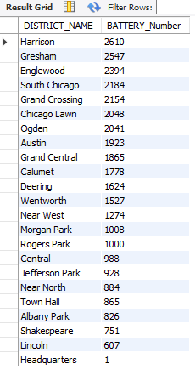

# Find out top 10 blocks which have the most crime records

SELECT

BLOCK, COUNT(DISTINCT (CRIME_ID)) AS CASES

FROM

finalproject.crime

GROUP BY BLOCK

ORDER BY CASES DESC

LIMIT 10;

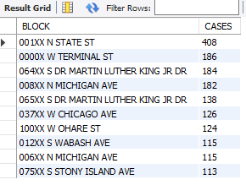

#Find out the crimes happened in each community area ordered by the amounts of crimes.

SELECT

cm.AREA_NUMBER,

Count(c.CRIME_ID) AS Crimecount

FROM

finalproject.crime as c

JOIN

finalproject.community as cm

JOIN

finalproject.fact_table as f

WHERE

c.CRIME_ID = f.crime_CRIME_ID

AND f.community_COMMUNITY_AREA_NUMBER=cm.AREA_NUMBER

GROUP BY f.community_COMMUNITY_AREA_NUMBER

ORDER BY Crimecount DESC;

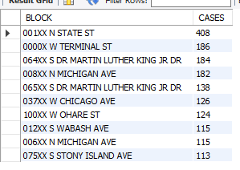

# Find out community areas with more than 20% poverty population

SELECT

community_AREA_NUMBER

FROM

finalproject.poverty

WHERE

POVERTYPOPULATION_2010 > 0.2;

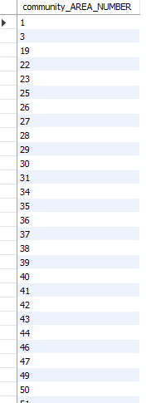

# Find out community areas with more than 30% population educated without degree and more than 40% population educated with degree

SELECT

community_AREA_NUMBER,EDUCATED_WITHOUTDEGREE, EDUCATED_WITHDEGREE

FROM

finalproject.education

WHERE

EDUCATED_WITHOUTDEGREE > 0.3 AND

EDUCATED_WITHDEGREE>0.4;

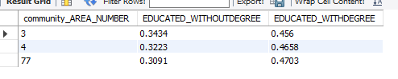

#Find out the crimes happened in each community area ordered by the amounts of crimes.

SELECT

cm.AREA_NUMBER,

Count(c.CRIME_ID) AS Crimecount

FROM

finalproject.crime as c

JOIN

finalproject.community as cm

JOIN

finalproject.fact_table as f

WHERE

c.CRIME_ID = f.crime_CRIME_ID

AND f.community_COMMUNITY_AREA_NUMBER=cm.AREA_NUMBER

GROUP BY f.community_COMMUNITY_AREA_NUMBER

ORDER BY Crimecount DESC;

